**Computing Overview 2023-2024 *Cycle A***

|  |  |  |  |  |
| --- | --- | --- | --- | --- |
| **Terms** | **Reception** | **Year 1 & Year 2** | **Year 3 & Year 4** | **Year 5 & Year 6** |
| **Autumn 1** | **General Computing Skills**  **Communication and Language**  **Expressive Arts**  **Literacy**  **Maths**  **Physical Development**  **PSED**  **Understanding the World** | 4 Weeks - Unit 1.1 Online Safety & Exploring Purple Mash  3 Weeks - Unit 2.5 Effective Searching | 3 Weeks - Unit 3.2 Online safety  2 Weeks - Unit 3.1 Coding  1 Week – Unit 4.1 Coding | 2 Weeks - Unit 6.2 Online safety  4 Weeks – Unit 5.1 Coding |
| **Autumn 2** | 2 Weeks - Unit 1.9 Technology outside school  2 Weeks - Unit 1.2 Grouping & Sorting  3 Weeks - Unit 1.4 Lego Builders | 1 Weeks - Unit 3.1 Coding  2 Week – Unit 4.1 Coding | 3 Weeks – Unit 5.1 Coding  1 Week – Unit 5.1 Coding  3 Weeks - Unit 6.6 Networks |
| **Spring 1** | 5 Weeks - Unit 2.6 Creating Pictures | 3 Weeks - Unit 3.3 Spreadsheets  3 Weeks – Unit 3.7 Simulations | 5 Weeks - Unit 6.3 Spreadsheets (Google Sheets) |
| **Spring 2** | 3 Weeks - Unit 1.8 Spreadsheets (Google Sheets)  3 Weeks - Unit 1.7 Coding (Part 1) | 4 Weeks - Unit 3.4 Touch Typing  2 Weeks - Unit 3.8 Graphing | 4 Weeks - Unit 6.4 Blogging  2 Weeks - Unit 6.6 Networks |
| **Summer 1** | 3 Weeks - Unit 1.7 Coding (Part 2)  1 Week - Unit 2.1 Coding (Part 1) | 6 Weeks - Unit 3.5 Email & Online Safety | 1 Week - Unit 6.6 Networks  5 Weeks - Unit 6.5 Text Adventures |
| **Summer 2** | 4 Weeks - Unit 2.1 Coding (Part 2) | 4 Weeks - Unit 3.6 Branching Databases  3 Weeks - Unit 3.7 Simulations | 6 Weeks - Unit 6.7 Quizzing |

**Computing Overview 2023-2024 *Cycle B***

|  |  |  |  |  |
| --- | --- | --- | --- | --- |
| **Terms** | **Reception** | **Year 1 & Year 2** | **Year 3 & Year 4** | **Year 5 & Year 6** |
| **Autumn 1** | **General Computing Skills**  **Communication and Language**  **Expressive Arts**  **Literacy**  **Maths**  **Physical Development**  **PSED**  **Understanding the World** | 4 Weeks - Unit 1.1 Online Safety & Exploring Purple Mash  3 Weeks - Unit 1.5 Maze Explorers (BeeBots) | 4 Weeks - Unit 4.2 Online safety  1 Week - Unit 3.1 Coding  1 Week – Unit 4.1 Coding | 2 Weeks - Unit 6.2 Online safety  3 Weeks – Unit 6.1 Coding  1 Weeks – Unit 5.1 Coding |
| **Autumn 2** | 5 Weeks - Unit 2.4 Questioning  3 Weeks Unit 2.2 Online Safety | 2 Week - Unit 3.1 Coding  2 Week – Unit 4.1 Coding | 2 Weeks – Unit 6.1 Coding  4 Weeks - Unit 6.4  Blogging |
| **Spring 1** | 5 Weeks - Unit 1.6 Animated Story Books | 6 Weeks - Unit 4.3 Spreadsheets | 6 Weeks - Unit 6.9 Spreadsheets (Google Sheets) |
| **Spring 2** | 3 Weeks - Unit 2.7 Making Music  3 Weeks - Unit 1.3 Pictograms | 6 Weeks - Unit 3.9 Presenting (Google Slides) | 5 Weeks - Unit 5.8 Word processing (Google Docs)  1 Week - Unit 6.6 Networks |
| **Summer 1** | 4 Weeks - Unit 2.3 Spreadsheets | 4 Weeks - Unit 4.5 Logo  2 Weeks - Unit 4.7 Effective Search | 6 Weeks - Unit 6.7 Quizzing |
| **Summer 2** | 4 Weeks - Unit 2.8 Presenting Ideas | 3 Weeks - Unit 4.6 Animation  2 Weeks - Unit 4.8 Hardware Investigators | 2 Weeks – Unit 6.6 Networks  4 Weeks - Unit 6.4 Blogging |

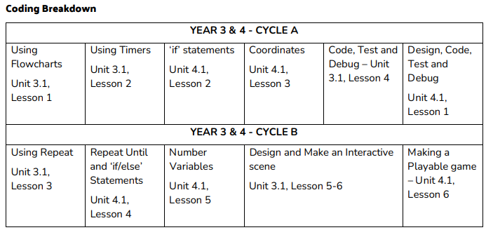

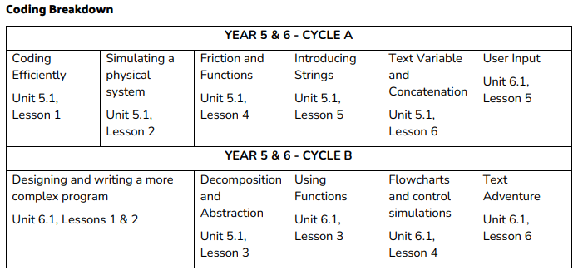

**Reception Computing Overview**

|  |  |  |
| --- | --- | --- |
| **General Computing Skills**  Mouse and Trackpad Skills  Keyboard Skills  Drawing Skills  Robots  Sounds | Photography  Technology Around Us  Hardware  Safety and Privacy  Quizzes | **Expressive Arts**  Being Imaginative and Expressive  Creating with Materials |
| **Communication and Language**  Listening, Attention and Understanding  Speaking | **Maths**  Number  Numerical Patterns | **PSED**  Building Relationships  Managing Self  Self-Regulation |
| **Literacy**  Word Reading  Writing  Comprehension | **Physical Development**  Fine Motor Skills  Gross Motor Skills | **Understanding the World**  People, Culture & Communities  Past & Present  The Natural World |

**Teacher Support with Computing:**

Purple Mash self service CPD: <https://training.2simple.com/>

Book CPD Sessions: [https://www.purplemash.com/#tab/teachers[4]/app/cpd/ProfessionalDevelopmentCourses](https://www.purplemash.com/#tab/teachers%5B4%5D/app/cpd/ProfessionalDevelopmentCourses)

Purple Mash user guides for all Tools: <https://www.purplemash.com/#tab/teachers/guides_and_resources>

Purple Mash Teacher Videos: Example - <https://www.purplemash.com/#tab/teachers/guides_and_resources/computing_sow/computing_sow_y3/computing_sow_y3_3-3/computing_sow_year3_unit_3_3_lesson_1>

(A tutorial video on how to use the resources in a lesson and tips on how to use the tools when teaching. Only available for some units)

**Teaching in Lesson Support:**

Purple Mash Lesson Slides: Example - <https://www.purplemash.com/#tab/teachers/guides_and_resources/computing_sow/computing_sow_y3/computing_sow_y3_3-3/computing_sow_year3_unit_3_3_lesson_1>

(Use these in class but also to check ahead of time about what you will cover and how activities are completed.)

Recording of work to be saved on Purple Mash if done on Purple Mash.

Work done on Google to be saved to personal/ shared drive:

Year 3/4

Cycle B Google Slides

Year 5/6

Cycle A Google Sheets

Cycle B Google Sheets and Google Docs

**Computing Planning and Teaching Task List:**

1. Plan lessons using Purple Mash documents from their Computing Scheme of work.
2. Assign 2Dos for the lesson. (This can be done in advance and scheduled for later)
3. Check teacher understanding of the learning using the teacher videos if available for the lesson.
4. Check the slides for the lesson planned and edit to match your adapted lesson plan.
5. Deliver the lesson using the slides as a visual support and children's work saved under the 2Do set.